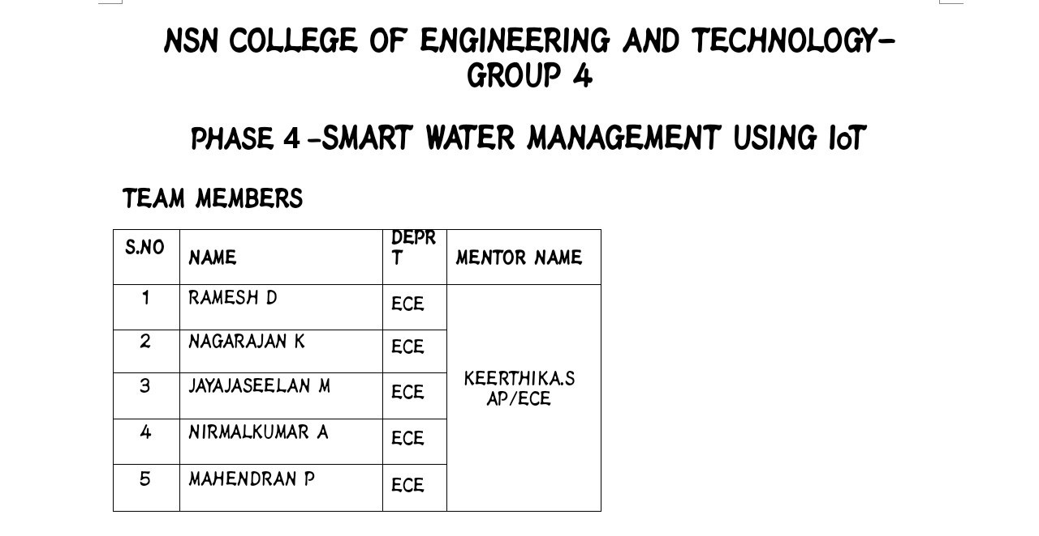
Block Diagram:
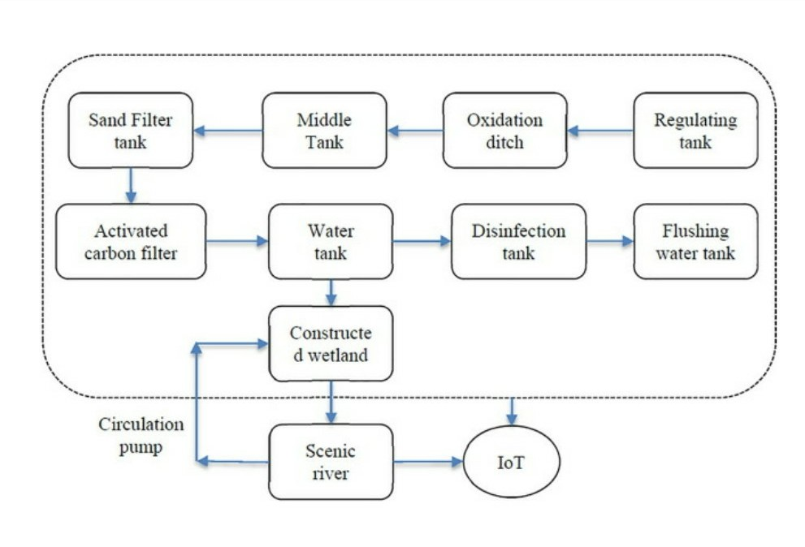
Regulating tank:
In case of severe weather such as a thunderstorm, the control tank helps to limit the flow of water. In the case of heavy rain, the water enters the tank with maximum flow and comes out of the tank in the upper part with a perfectly controlled flow.

Oxidation ditch:
The key difference between oxidation pond and oxidation ditch is that an oxidation pond is a large, shallow pond designed to treat wastewater through the interaction of sunlight, bacteria, and algae, whereas an oxidation ditch is a modified activated sludge that involves biological treatment processes which are utilizing long solids retention times for the removal of biodegradable organics.

Middle tank:
Medium tanks had the speed and maneuverability of light tanks, but the armor and weapons of heavy tanks. Armies used medium tanks to exploit weaknesses along the flanks of an enemy position, or as a reaction force to shore up a line that was under attack.

Sand Filter tank:
Sand filters are actually a type of tank that has an inlet and an outlet valve and nozzles with sand and silica coating. Particles suspended in water will not pass through the filter and nozzle covered with sand grains, and eventually the water outlet will be clean and purified.

Activated carbon filter:
Activated carbon filters are generally employed in the process of removing organic compounds and/or extracting free chlorine from water, thereby making the water suitable for discharge or use in manufacturing processes.

Water tank:
A water tank is a container for storing water. They are used to provide storage of water for use in many applications, drinking water, irrigation agriculture, fire suppression, agricultural farming, both for plants and livestock, chemical manufacturing, food preparation as well as many other uses. Water tank parameters include the general design of the tank, and choice of construction materials, linings.

Disinfection tank:
Chlorination is the most common form of disinfection and successfully controls many micro-organisms. CALCULATING THE SIZE OF YOUR TANK FOR CHLORINATION. Tanks come in a variety sizes ranging from 750 L (165 gallons) to over 50 000 L (11 000 gallons).

Flushing water tank:
An RV black tank flush is a cleaning system that works in tandem with your regular RV tank dumping procedure. For example, you generally dump your black tank and then flush out the sewer hose by dumping the contents of your gray tank immediately thereafter.

Constructe wetland:
A constructed wetland is an artificial wetland to treat sewage, greywater, stormwater runoff or industrial wastewater. It may also be designed for land reclamation after mining, or as a mitigation step for natural areas lost to land development.

Scenic river:
Those rivers or sections of rivers that are free of impoundments, with shorelines or watersheds still largely primitive and shorelines largely undeveloped, but accessible in places by roads.

Circulation pump:
Boiler circulating pumps circulate water within the boiler to enhance boiler operation. They take suction from a header connected to the bottom of the boiler drum and discharge through additional tube circuits. This means the water pumped is at boiler temperature and pressure.

IoT:
The term IoT, or Internet of Things, refers to the collective network of connected devices and the technology that facilitates communication between devices and the cloud, as well as between the devices themselves.

Python Script:
To implement a smart water management system using IoT and Python, you will need the following components:

IoT devices/sensors: These could include water flow sensors, moisture sensors, water level sensors, etc. These sensors will provide data on water usage, soil moisture, and water levels.
IoT platform: You will need an IoT platform to receive data from the sensors, process it, and send control commands. IBM Watson IoT Platform, AWS IoT Core, or Google Cloud IoT are popular choices.
Actuators: These devices will be controlled based on the data received from the sensors. Examples include solenoid valves, pumps, or sprinklers.
Python script: This script will interface with the sensors, collect and process data, and send control signals to the actuators.

Here's an example Python script that demonstrates how to monitor soil moisture levels and control a water pump using the MQTT protocol and the Adafruit IO platform:
import time
import RPi.GPIO as GPIO
from Adafruit_IO import MQTTClient

# Set the credentials for the Adafruit IO platform
ADAFRUIT_IO_USERNAME = '<YOUR_AIO_USERNAME>'
ADAFRUIT_IO_KEY = '<YOUR_AIO_KEY>'

# Set the GPIO pin number for the water pump
PUMP_PIN = 18

# Set the moisture threshold
MOISTURE_THRESHOLD = 50

# Create an MQTT client for the Adafruit IO platform
client = MQTTClient(ADAFRUIT_IO_USERNAME, ADAFRUIT_IO_KEY)

# Define the callback function for handling incoming MQTT messages
def on_message(client, feed_id, payload):
print('Received data: ', payload)

# Set the callback function for incoming MQTT messages
client.on_message = on_message

# Connect to the Adafruit IO MQTT broker
client.connect()

# Subscribe to the soil moisture feed
moisture_feed = '<YOUR_MOISTURE_FEED>'
client.subscribe(moisture_feed)

# Configure the GPIO pin for the water pump
GPIO.setmode(GPIO.BCM)
GPIO.setup(PUMP_PIN, GPIO.OUT)

while True:
# Get the latest soil moisture reading from the Adafruit IO feed
moisture = client.receive(moisture_feed).value

# If the soil moisture is below the threshold, turn on the water pump
if moisture < MOISTURE_THRESHOLD:
GPIO.output(PUMP_PIN, GPIO.HIGH)
print('Water pump turned on')
else:
GPIO.output(PUMP_PIN, GPIO.LOW)
print('Water pump turned off')

time.sleep(5) # Adjust the delay as per your requirement

# Clean up GPIO pins and disconnect from the Adafruit IO broker
GPIO.cleanup()
client.disconnect()

Make sure to replace <YOUR_AIO_USERNAME> , <YOUR_AIO_KEY> , <YOUR_MOISTURE_FEED> , and adjust the code based on your specific sensors, actuators, and their reading/control logic.

This is a basic example, and you can expand it to handle multiple sensors, implement data analysis, and incorporate other functionalities based on your smart water management system requirements.

Smart water management using IoT (Internet of Things) with web development technology is a promising area that combines hardware, software, and data analysis to optimize water usage. Implementing this system involves using sensors to collect data from various sources, transmitting the data to a central server, and using web development technologies to visualize and analyze the data in real-time. Below, I outline the steps to create a smart water management system using IoT and web development technologies, along with simulated outputs.

### 1. *IoT Device Setup:*
- *Sensors:* Use water flow sensors, moisture sensors, and other relevant sensors to measure water usage and soil moisture levels.
- *Microcontroller:* Connect sensors to microcontrollers (like Arduino or Raspberry Pi) to collect data.
- *Communication:* Use communication modules like Wi-Fi, LoRa, or GSM to transmit data to the central server.

### 2. *Centralized Server:*
- *Database:* Set up a database (like MySQL or MongoDB) to store sensor data.
- *Backend Development:* Use a backend framework (Node.js, Django, Flask) to handle data processing and storage.
- *API Development:* Create APIs to handle data transmission between IoT devices and the server.

### 3. *Web Development:*
- *Frontend Development:* Use HTML, CSS, and JavaScript frameworks (like React, Angular, or Vue.js) to create an interactive web interface for users.
- *Real-time Updates:* Implement WebSocket or Server-Sent Events for real-time updates on the web interface.
- *Data Visualization:* Use libraries like D3.js or Chart.js to create visually appealing charts and graphs for data visualization.

### 4. *Simulation Outputs:*
- *Dashboard:* Create a dashboard showing real-time water usage, soil moisture levels, and any leakages. Simulated data can be used initially.
- *Usage Analytics:* Display historical data and analytics to show water usage patterns over time.
- *Alerts:* Implement an alert system to notify users about abnormal water usage or leakages.
- *User Interface:* Develop an intuitive user interface where users can set water usage limits, view recommendations, and control irrigation systems remotely.

### 5. *Testing and Optimization:*
- *Simulation:* Use simulated data to test different scenarios and ensure the system responds correctly.
- *Optimization:* Optimize the system for efficiency, considering factors like power consumption, data transmission frequency, and server load.
- *Security:* Implement security measures to protect data integrity and user privacy.

### 6. *Deployment:*
- *Cloud Hosting:* Deploy the server and database on cloud platforms like AWS, Azure, or Google Cloud for scalability.
- *IoT Devices:* Deploy the IoT devices in the target environment, ensuring they are securely connected to the server.

### 7. *Maintenance and Updates:*
- *Monitoring:* Implement monitoring tools to track system performance and detect any issues in real-time.
- *Software Updates:* Regularly update the software to add new features, improve security, and enhance user experience.
- *User Support:* Provide user support and maintenance services to address user queries and issues.

By following these steps and incorporating simulated data for testing, you can create a robust smart water management system using IoT and web development technologies. Remember to keep user experience, data accuracy, and system security at the forefront of the development process.

Proposed System:

5V and 3.3Vare used to provide power to sensors and modules when connecting it to. The temperature sensor LM35IC has been used for sensing the temperature. It is an integrated circuit sensor that can be used to measure temperature with an electrical output proportional to the temperature. The temperature can be measured more accurately with it than using a thermistor. The sensor circuit ryis sealed and not subject to oxidation, etc. It is a three terminal sensor used to measure the surrounding temperature ranging from
-55 degree centigrade to 150 degree centigrade.

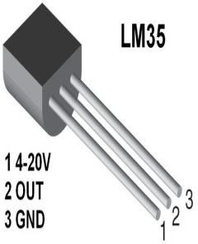
Water flow sensor are installed at the water sources or pipes to measure the rate of flow of water and calculate the amount of water flowed through the pipe. Rate of flow of water is measured as liter per hour or cubic meters. Water flow sensor consists of plastic valve from which water can pass. A water rotor along with a hall effect sensor is present and measure the water flow. The main working principle behind the working of this sensor is the hall effect. According to this principle , in this sensor , a voltage difference is induced in the conductor due to rotation of the rotor. This induced voltage difference is transverse to the electric current.
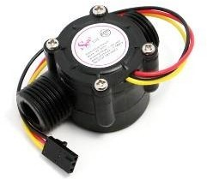

The HC-SR04 ultrasonic module is a module that can provide noncontact measurement within the range of 2cm to 400cm with an ranging accuracy that can reach 3mm. It works on the principle of echolocation. The ultrasonic sensor as a trigger and an echo pins. The Arduino provides a high signal of 10microseconds to this pin. The sensor is trigged, it send out a 840khz to the surface of the water. On getting to the surface of the water, the wave is echoed back to the sensor and the Arduino reads the echo pin to determine the time spent between the triggering and receiving of the echo.
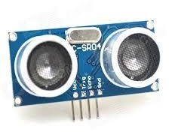
The Arduino Uno is used as microcontroller in this structure , it has 14 propelled data/yield pins of which the user are using 6 pins for interfacing sensors-waterflow , Ultrasonic and temperature. Interfacing the wi-fi module ESP8266 with Arduino for giving an electronic system. Arduino is a microcontroller board subject to the Atmega328p. A 16 MHz quartz valuable stone, a USB affiliation, a power jack, a reset.
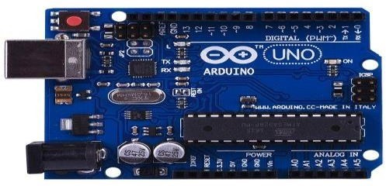
The ESP8266 can do either offloading wi-fi frameworks organization limits from another application processor or encouraging an application. The ESP8266 wi-fi module is a free SOC with facilitated TCP/IP show stack that can giveany microcontroller to access to the wi-fi range. This module has an earth shattering enough prepared getting ready and limit capacity that empowers it to be composed with the sensors.
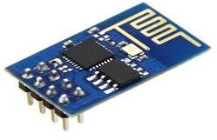
The SIM900 is a quad-band GSM/GPRS solution is a SMT module which can be embedded in the customer applications. Featuring an industry standard , interface the SIM900 delivers GSM/GPRS 850/900/1800/1900MHz performance for the voice, sms , data with small power consumption.
A 16*2 LCD has two registers namely, command and the data. The register select is used to switch from one register to other. RS=0 for command register and RS=1 for data register.

Rrsult

management by using the IOT.
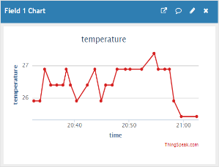
temperature in water tank

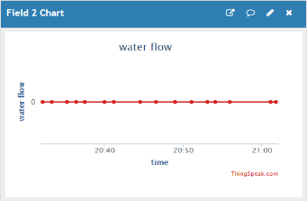
Water is not in usage
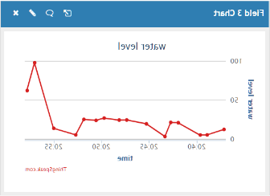
Water level sensor

